Shropshire

Web Site

Project Notebook

Table of Contents

Introduction 3

Web Site Procedures 4

Add New Item 4

Generate the Pages 8

Tools 9

Cloud Services 10

Installation and Configuration 10

Ruby and Jekyll 10

AutoHotKey Script Database Application 12

# Introduction

To learn more about the beautiful county of Shropshire, I use my photographs to investigate the history and explore the landscape.

My photographs are presented via a Web Site, which is organised into the following areas:

* History
* Landscape
* Castles
* Churches
* Houses
* People
* Folklore
* Places
* Gardens
* Other

The Web Site is hosted in my GitHub repository:

<https://dmfbsh.github.io/>

It is a static site, generated using [Jekyll](https://jekyllrb.com/), Jekyll is Ruby based.

The Web Site is developed using [Liquid](https://shopify.github.io/liquid/basics/introduction/) templates to define the presentation layout and data is contained in [YAML](https://yaml.org/) files. The YAML files are generated from [Markdown](https://www.markdownguide.org/) files, this makes it easier to edit the source content.

All assets relating to the project are held in my GitHub repository, which is cloned to the OneDrive in the folder:

C:\Users\David\Documents\OneDrive\Documents\My Documents\GitHub\dmfbsh.github.io

# Web Site Procedures

## Add New Item

1. In ACDSee select a photo for the item
2. In ACDSee assign the selected photo to one or more categories in the Shropshire category

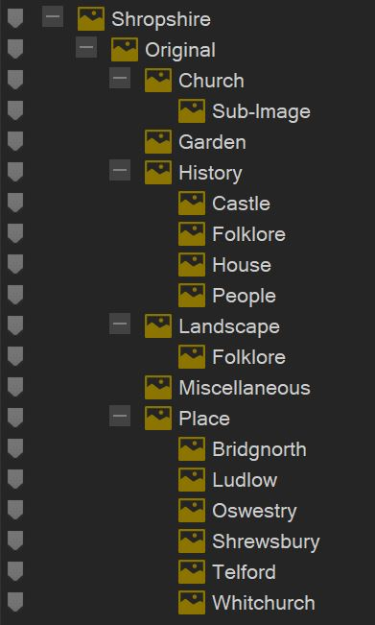

1. Create a new record for the item in the AHK Shropshire Photography application, this will also create a folder in the directory:

E:\My Pictures\Published\Shropshire

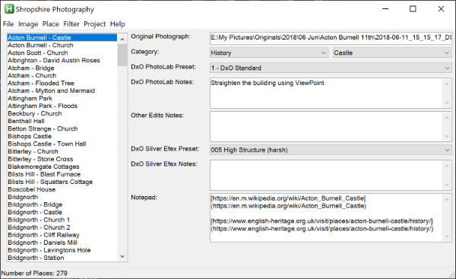

1. In the AHK Shropshire Photography application, assign the original photo to the item



1. In DxO PhotoLab develop the photo and export to disk using the Shropshire Photography output option

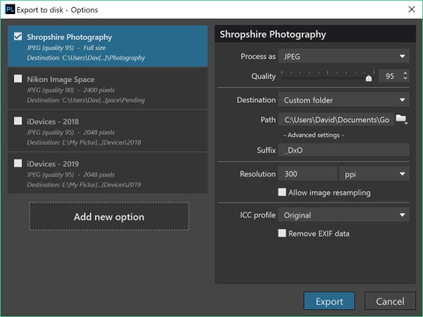

1. In the AHK Shropshire Photography application record any adjustments made in DxO PhotoLab
2. Move the developed photo to the item's folder - use the Move function in the AHK Shropshire Photography application to do this
3. Edit photo as required with Affinity Photo and / or Luminar
4. In the AHK Shropshire Photography application record any adjustments made in the photo editor(s)
5. If history, create a B&W version of the photo (create a copy of the photo and suffix the filename with _bw), do this in ACDSee using the plugin DxO Silver Efex Pro
6. If history, in the AHK Shropshire Photography application record any adjustments made in DxO Silver Efex Pro
7. Generate a thumbnail for each category to which the item is assigned to - for the history page the thumbnails are 400x400 and for all other pages the thumbnails are 500x500 - thumbnails are generated using ACDSee batch export tasks

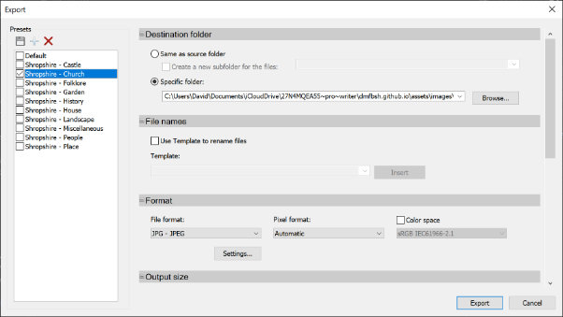

1. Add the item to the MD file for the page(s) on which it will feature – use the function in the AHK Shropshire Database application to generate a template (this will insert the correct filename for the photo)
2. Record the changes made to the Web Site as a post in the blog – there is a function in Directory Opus to create a new post, otherwise add to an existing one

Additional steps if the item is a church:

1. Change the colour on Google map

<https://www.google.co.uk/maps/d/>

1. Change the status in the AHK Shropshire Churches application (this will automatically update the status (i.e. list) in Trello)

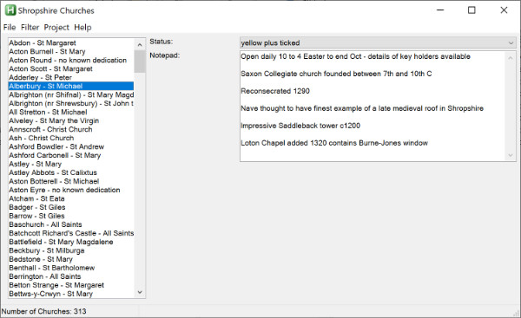

1. Use the AHK Shropshire Churches application to generate a new GPX file (for the UK Map app) – the GPX file should then be transferred to the iOS devices and loaded into the UK Map app

Additional steps if the church has sub-items:

1. In ACDSee identify any photos for the sub-images
2. In ACDSee assign the selected photos for the sub-images to the Church > Sub-Image category
3. In DxO PhotoLab develop the photos for the sub-images and export to disk using the Shropshire Photography output option
4. Add the filenames of the sub-images to the MD file entry for the church
5. Crop and resize the sub-images to be 240px high and save in the assets\images\churches-sub folder - there is an Export preset in ACDSee for this, the original DxO files can then be deleted

## Generate the Pages

1. Convert the MD files into the YML data files - there is a Ruby script to do this:

convert_md_to_yml.rb

1. Generate a YML data file of recent photos - there is a Ruby script to do this:

generate_recents.rb

1. Generate the local copy of the statis Web Site:

jekyll build

1. Commit the changes to the GitHub repository (master branch) - this is done using the GitHub desktop application

# Tools

The following tools are used by the project:

* MS Windows 10
  + Development Tools
    - Ruby
    - Jekyll
    - UltraEdit
    - Typora
    - AutoHotKey
    - GitHub Desktop
    - DB Browser (SQLite)
  + Cloud Services
    - GitHub
    - Trello
    - Google Maps (accessed via the Web Browser)
  + Photo Editors
    - ACDSee Photo Studio Professional
    - DxO PhotoLab
    - DxO Nik Silver Efex Pro
    - Affinity Photo
    - Luminar 4
    - Landscape Pro
* iOS
  + Working Copy (GitHub client)
  + UK Map
  + Trello

## Cloud Services

The Cloud Services and the apps used to access them are illustrated below:



## Installation and Configuration

### Ruby and Jekyll

To install Ruby and Jekyll, do the following:

1. Install Ruby
   1. Download and install Ruby with Devkit from <https://rubyinstaller.org/downloads/>
   2. Run the ***ridk install*** step on the last stage of the installation wizard
2. Install Jekyll
   1. Install the gems: ***gem install jekyll bundler***
   2. Check the version: ***jekyll -v***

A project - Shropshire Web Site - is set up in UltraEdit to ease access to the files.

UltraEdit is installed with no specific configuration. A project - Shropshire Web Site - has been set up to allow easy access to the files, and provide shortcuts to access the various tools and scripts.

Typora is installed with no specific configuration.

AutoHotKey (64-bit) is installed, with no additional configuration.

GitHub desktop is installed, with no additional configuration.

DB Browser (SQLite) is installed, with no additional configuration.

# AutoHotKey Script Database Application

The status of the project is maintained in an SQLite3 database. This is accessed through a bespoke AutoHotKey scripted application.

AHK - 64 bit

SQLite DLL - 64 bit

https://github.com/AHK-just-me/Class_SQLiteDB

## Maps

The following maps are maintained in Google Maps ([My Maps](https://www.google.co.uk/maps/d/)) and are used by the Shropshire Web Site to show places of interest in the respective towns:

- Bridgnorth

- Ludlow

- Oswestry

- Shrewsbury

- Telford

- Whitchurch

The following map is maintained in Google Maps ([My Maps](https://www.google.co.uk/maps/d/)) and is used by the Shropshire Web Site to show the locations of the Castles:

- Shropshire - Castles

The following maps are maintained in Google Maps ([My Maps](https://www.google.co.uk/maps/d/)) and are used by the Shropshire Web Site to show the locations of the Churches (and which have been visited):

- Shropshire - Churchs - North

- Shropshire - Churches - South

The following maps are maintained in the iOS UK Map app:

- Shropshire - Churches

- Shropshire - Hills

- Shropshire - Places

### Shropshire - Churches

Used to identify which churches have been visited (green) and which are planned to be visited (yellow). Also includes notes of relevance such as opening times and things to look out for.

Edits should be made in the UK Map app on the iOS devices. Any changes must then be propagated as follows:

- Share the updated GPX file to the OneDrive.

- Download the GPX file from the OneDrive to the other iOS device and import into the UK Map app.

- Download the GPX file to the GitHub repository on the laptop - this is done using GoodSync.

- Convert the GPX file to an Excel spreadsheet - open the file using Excel and select the option "As a read-only workbook" to import the GPX data. This makes the notes more readable.

### Shropshire - Hills

Used to identify the locations of the various hills.

Notes relating to the hills are held in the OneNote notebook.

Edits should be made in the UK Map app on the iOS devices (although the GPX file is not expected to change). Any changes must then be propagated as follows:

- Share the updated GPX file to the OneDrive.

- Download the GPX file from the OneDrive to the other iOS device and import into the UK Map app.

- Download the GPX file to the GitHub repository on the laptop - this is done using GoodSync.

### Shropshire - Places

Used to identify the locations of places of interest (for visiting).

Notes relating to the places are held in the OneNote notebook.

Edits should be made in the UK Map app on the iOS devices. Any changes must then be propagated as follows:

- Share the updated GPX file to the OneDrive.

- Download the GPX file from the OneDrive to the other iOS device and import into the UK Map app.

- Download the GPX file to the GitHub repository on the laptop - this is done using GoodSync.

Some places are also put in The Photographer's Emphemeris.